Architecture of web

1. MVC- Model view Controller4

2. MVP – Model view Presetation

3. MVVM – model view view model

To create a website we need to create UI pages

port no is unique for every system which process the application

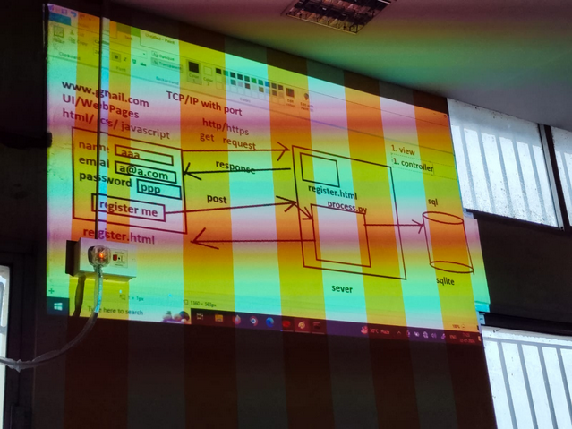2 tier application

MVT

root   
| - urls.py --> routing from browser

| - views.py --> controller of the class+++++es

|- models.py --> python classes to represent classes

| - templates

| - register.html --> all the html files

to map from models to db we use **migration process**

Workflow

pip3 –version

if not installed -> sudo apt install python3 python3-pip

sudo pip3 install virtualenv

mkdir and cd to there

virtualenv venv

python3 -m venv venv

source venv/bin/activate

pip install django

django-admin startproject proj1

cd proj1

python manage.py runserver

**creating ORM3**

python manage.py makemigrations

python manage.py migrate

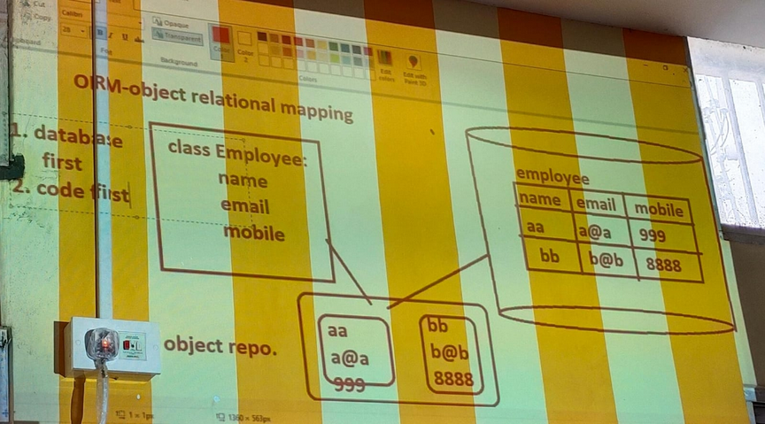

What is code-first approach – Django follow code first approach which means the code if first created then acc to code rows are generated

This is **reverse engineering**

bcz usually (other software like .net ) creates database first and acc to is code is generated to operate on it

When we are working on multiple classes based on the requirements at that time we need to create class relationship based on the logical requirement

there are 3 types of class relationship

- has a relationship

- aggregation

- is a relationship

- inheritance

- uses a relationship

-